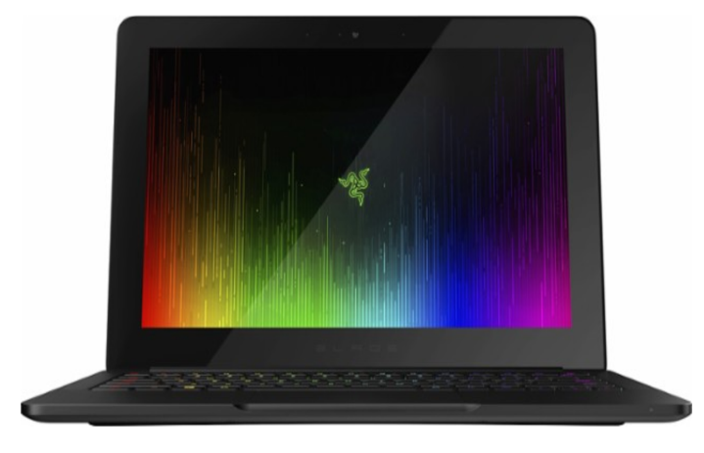Razer Stealth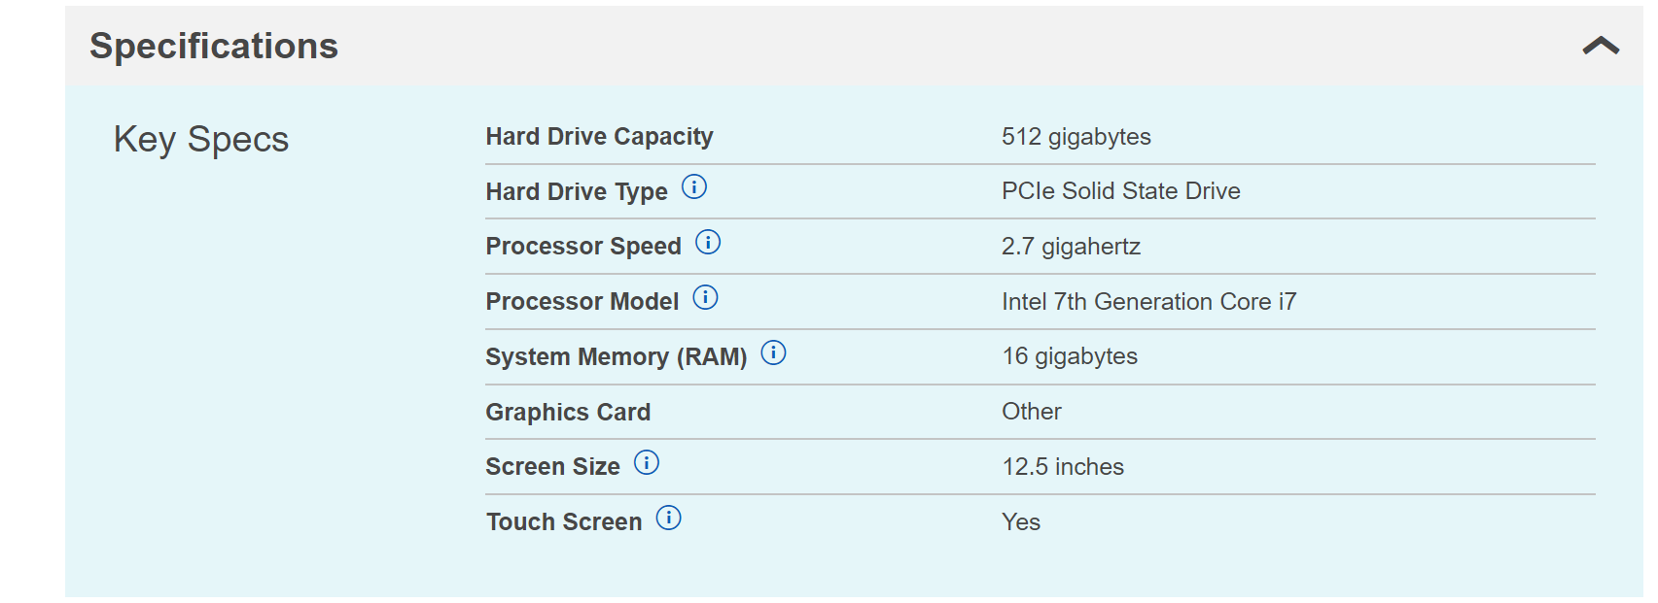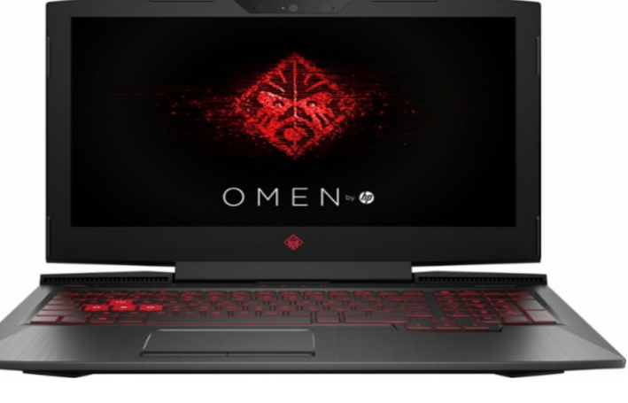HP OMEN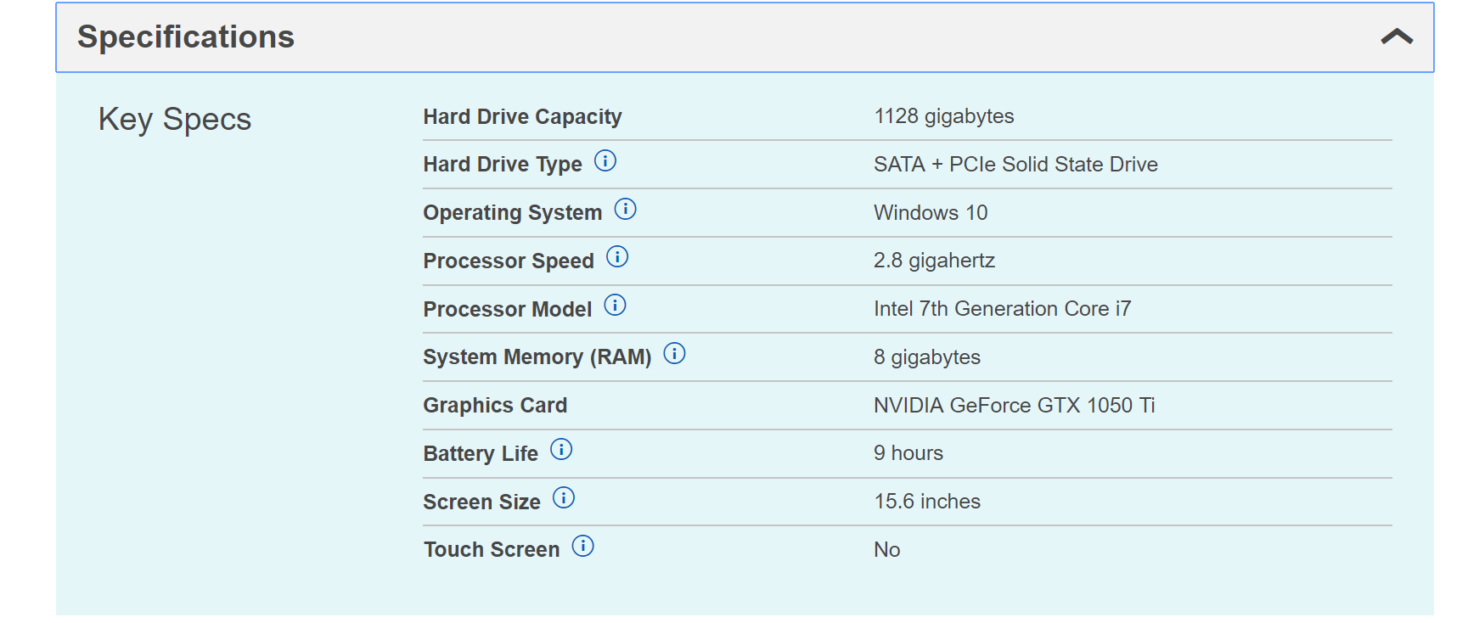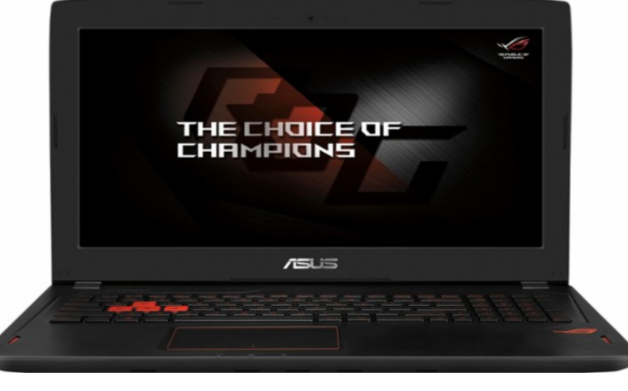 ASUS ROG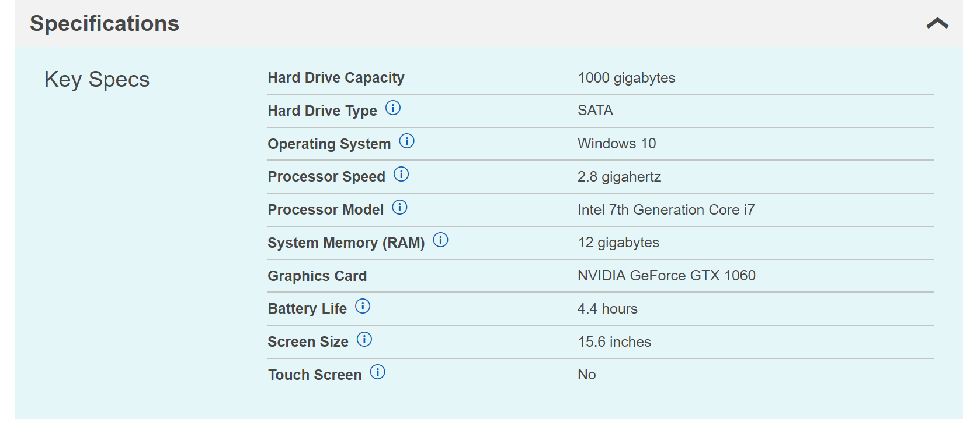

Out of all the laptops, the HP Omen is the best due to its affordability and with its sufficient specifications such as its hard drive capacity and battery life for gaming and multitasking. The worst would be the Razer Stealth due to its slower processor speed compared to the other laptops.